Grazioso Salvare Rescue Dog Dashboard
Student Name: Brandon Shank
Course: CS 340 – Client/Server Development
Project: Project Two – Interactive Dashboard

Project Overview
For Grazioso Salvare, we built an interactive web-based dashboard to filter and explore all information in their animal shelter. The information is stored in a MongoDB database.
The application connects a custom CRUD Python object to a Dash interface. The interface includes filters, charts, and a map.

Tools and Technologies Used
- Python
- MongoDB
- PyMongo
- Dash (Plotly Dash Framework)
- Pandas
- JupyterDash
- Dash Leaflet

Tool Rationale and Framework Explanation
The database we chose was MongoDB, which is a NoSQL database. In a NoSQL database, data is stored in “documents” in the database that are flexible and would look something like JSON objects. This makes it easy to work with in Python and it has a great query language for searching through the data and filtering records. The dashboard was built using the Dash framework. Dash is a framework for building web applications written in Python. It allows you to build interactive web-based graphical applications using a simple function of user input variables, such as dropdown menus, and render output such as tables, graphs, and maps given the output of the function.
Resources used:

https://www.mongodb.com
https://dash.plotly.com

System Functionality
The dashboard components are connected using Dash callbacks, allowing user interactions to dynamically update the table, chart, and map in real time.
- Interactive filtering using dropdown selection
- Dynamic data table displaying animal records
- Real-time chart showing top 10 breeds
- Interactive map updated based on selected animal
- Loading indicator for updates on the site

Dashboard Screenshots

Figure 1: Initial Dashboard (Reset Filter)
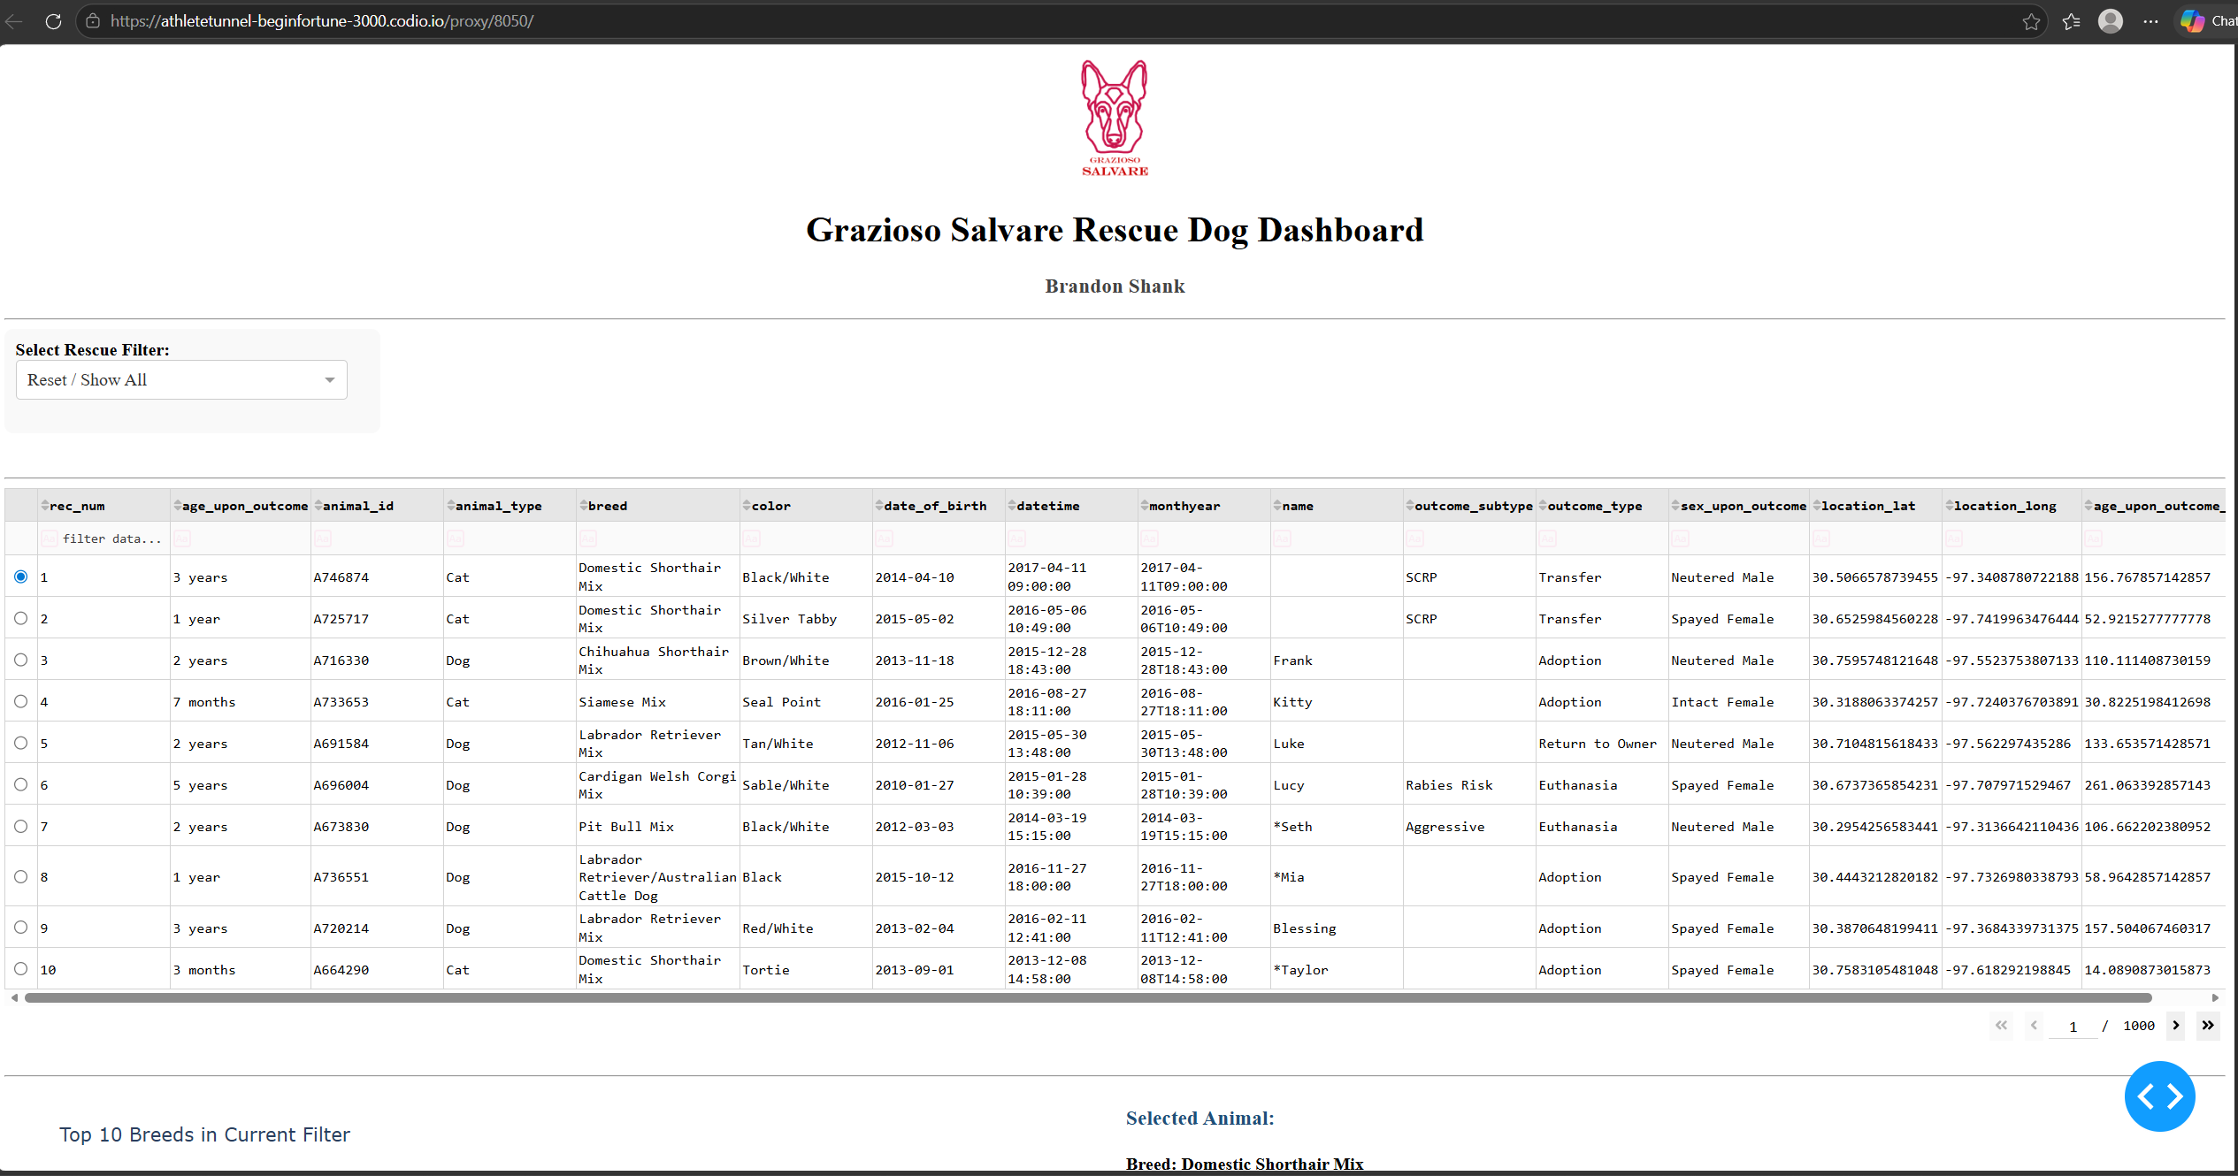

Figure 2: Water Rescue Filter Applied
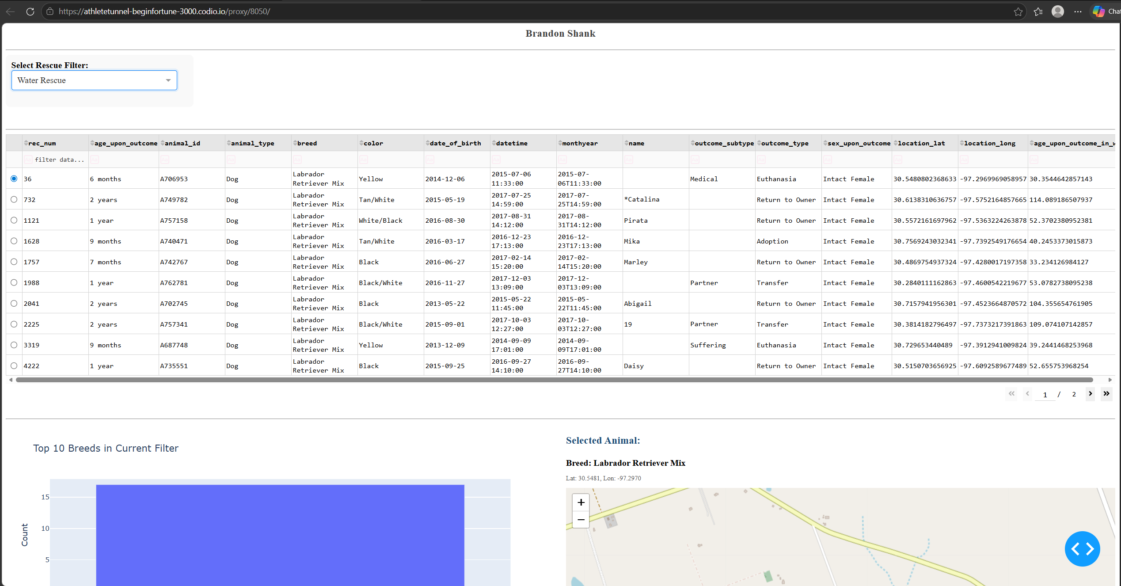

Figure 3: Mountain Rescue Filter Applied
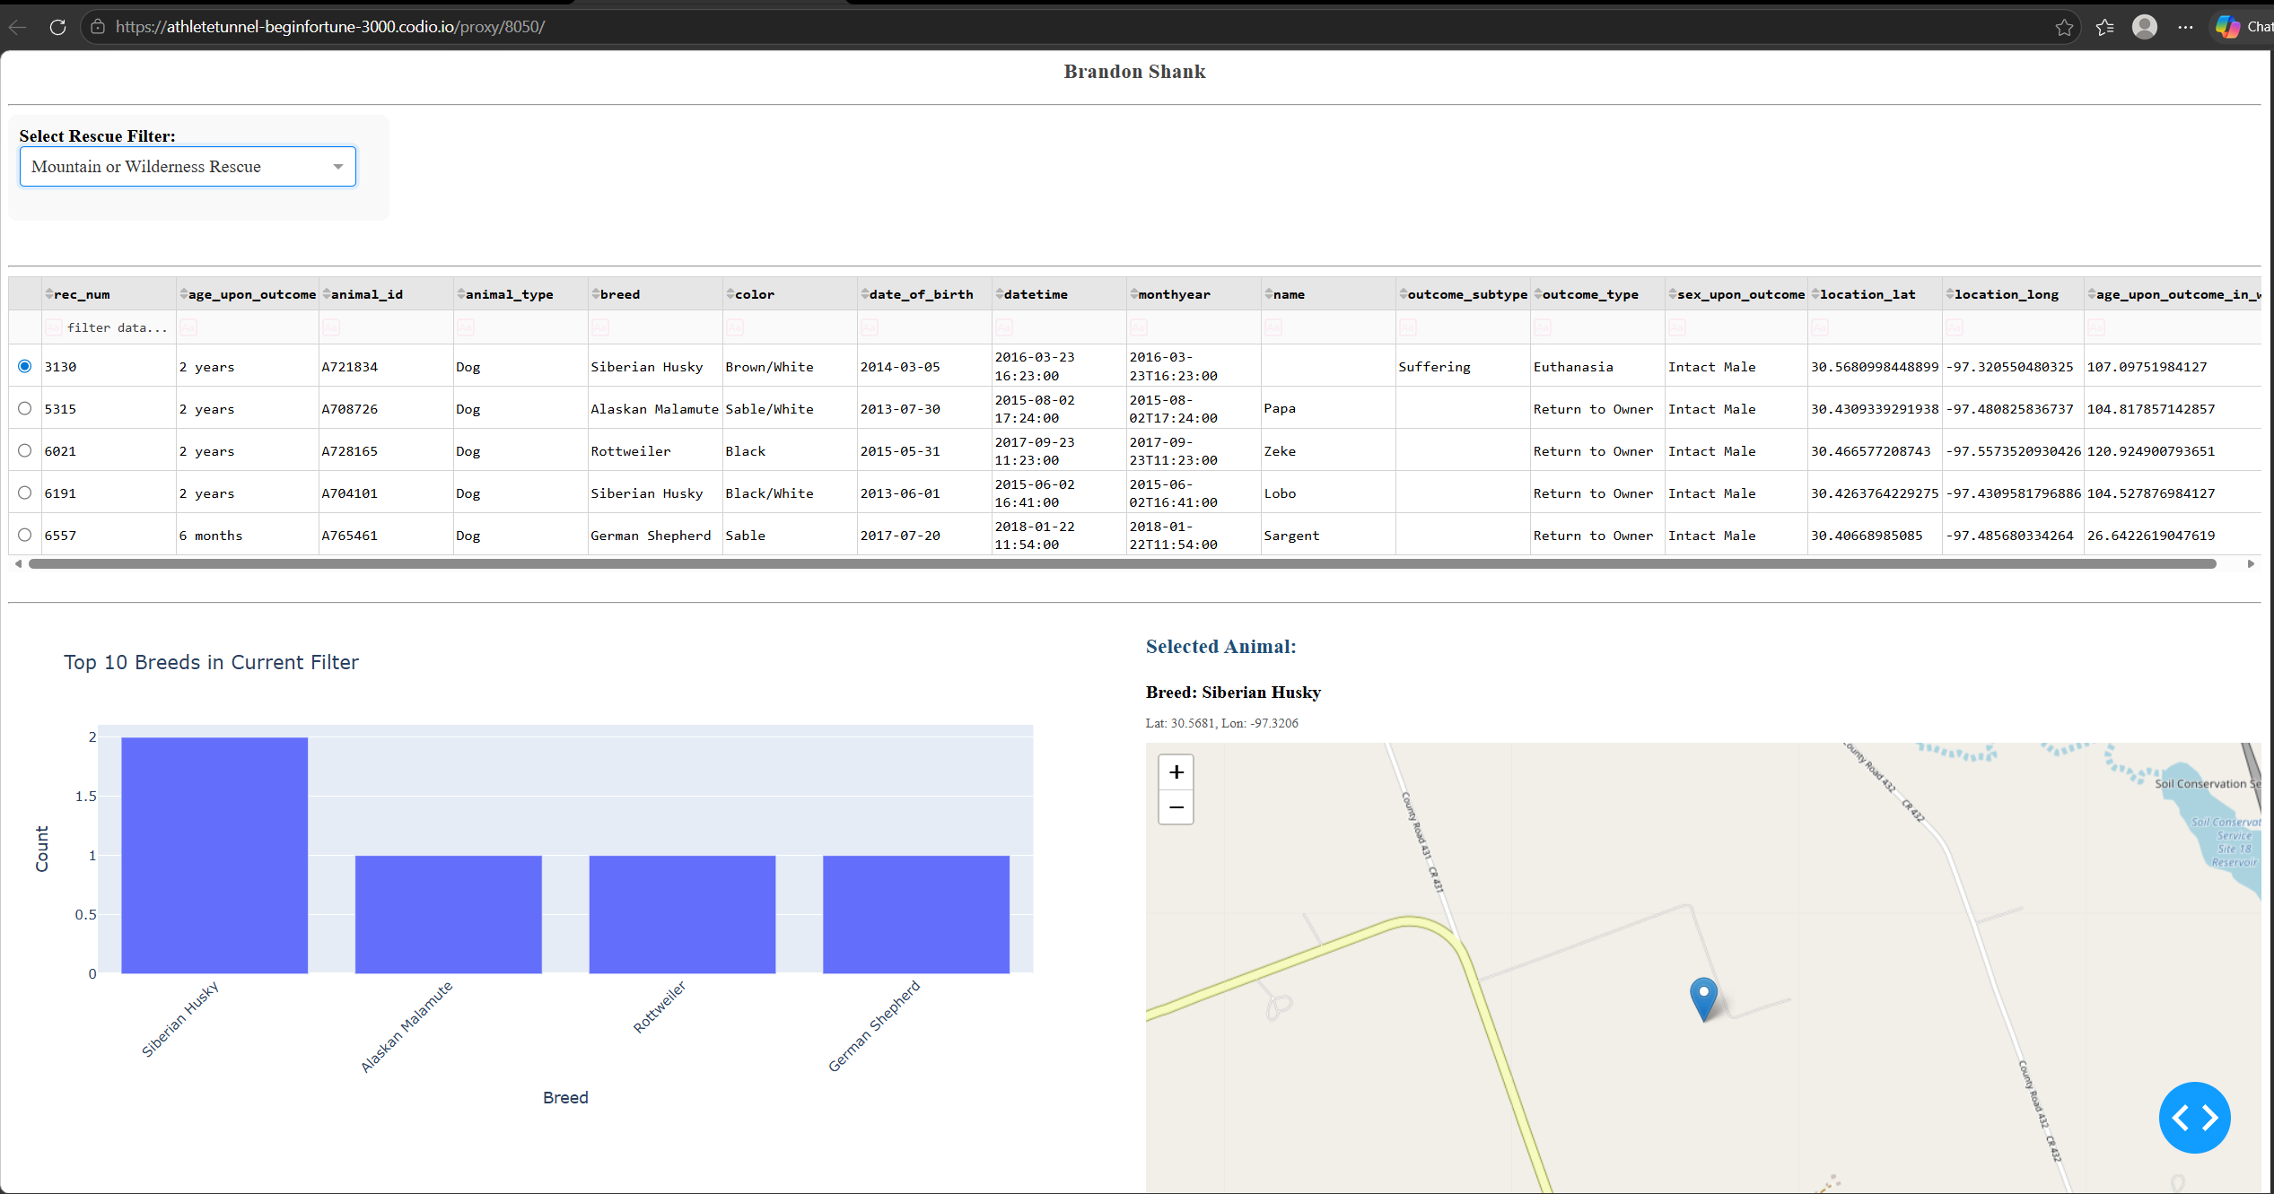

Figure 4: Disaster Tracking Filter Applied
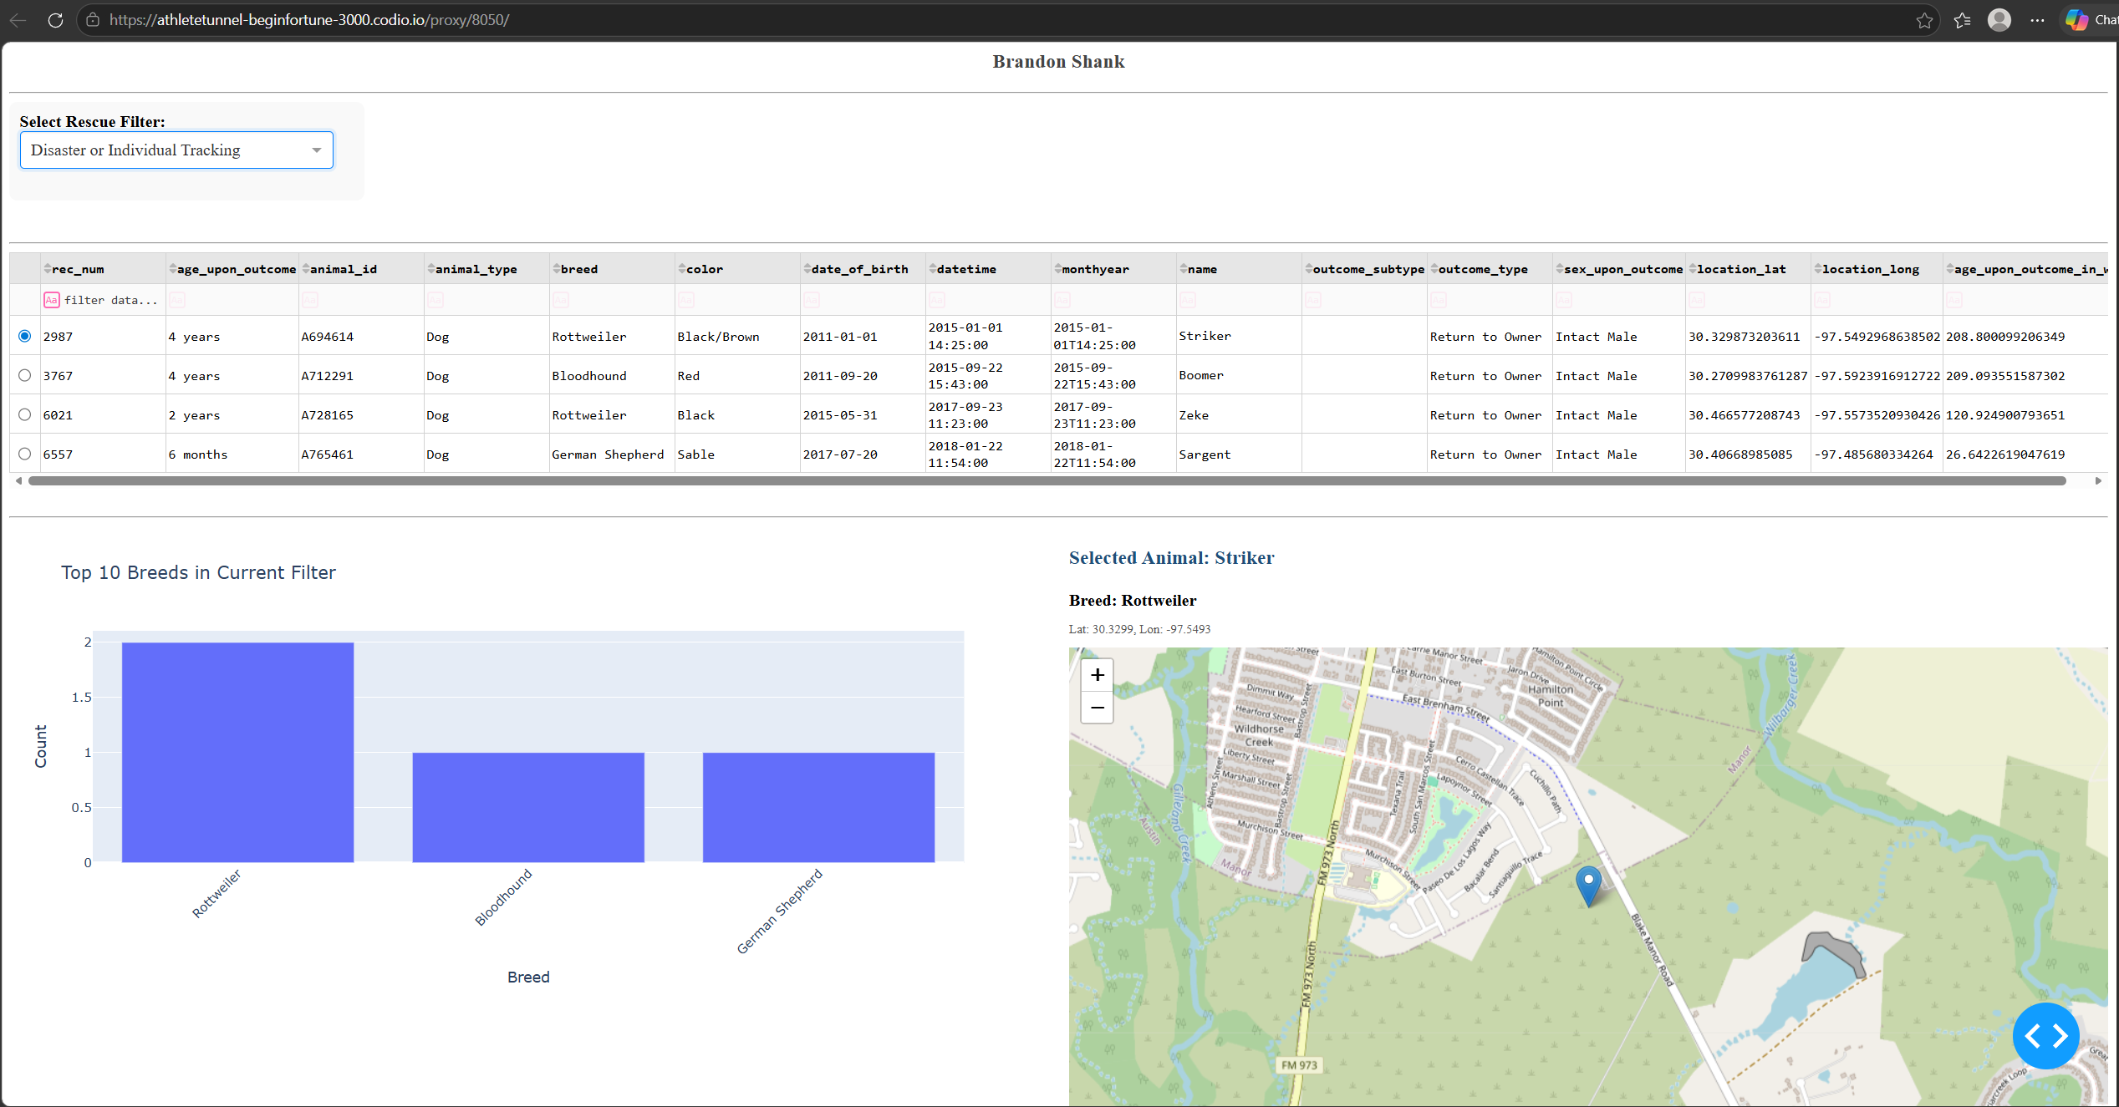

Figure 5: Row Selection and Map Update
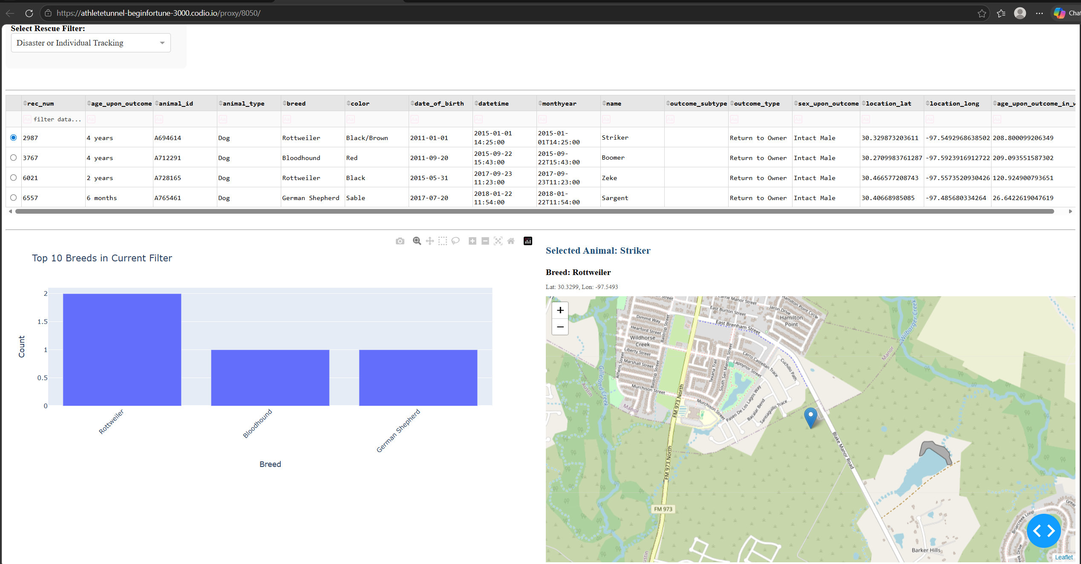

Reproduction Instructions
To reproduce this project, follow these steps:
Step 1: Setup MongoDB
Install MongoDB and ensure the Austin Animal Center dataset is imported into the aac database.

Step 2: Configure the CRUD Module
Ensure the file CRUD_Python_Module.py is in the same directory and uses the following credentials:
- Username: aacuser
- Password: aacpassword

Step 3: Run the Dashboard
Open the Jupyter Notebook file and run all cells. The dashboard will launch using JupyterDash.

Challenges Encountered
My map wasn't loading when I was viewing a record, so I added a loading indicator to handle that situation.
I had trouble integrating the new CRUD module into my existing dashboard, but a file rename, updating the file name in the includes, and renaming the import at the top of the file seem to be working.

Conclusion
Connect to a MongoDB database and create a Python web-based dashboard that allows you to filter the data and then view it in both a graph and a map. The dashboard should be very interactive so you can easily update it as you change the filters.

